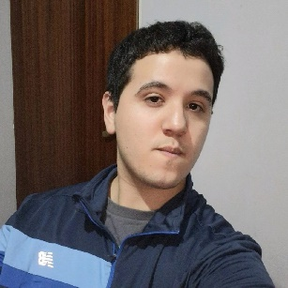
TIMOTEO GÜERINI
Mataderos, CABA, CP:1440, Argentina
Birth date: 04/30/1999
Email: timoten.99@gmail.com
Portfolio: https://tguerini.github.io/portfolio-timoteoguerini/
Phone number: +541162040576
Nationality: Argentina

Professional focus and profile
Computer engineer with 2 years of experience, specializing in systems analysis and software development. I have participated in projects that provided me with the skills to develop software from scratch, using technologies such as Python, JavaScript, TypeScript, Java, Springboot, C#, SQL, NoSQL, MongoDB, React, Redux, Node, AWS, and Git. My thesis project involved creating a tool for teachers to adapt content for students with SLD (Specific Learning Disorder). I am passionate about collaborating with teams, and I enjoy teaching and learning from my colleagues.
Skills
Python - Javascript – Typescript – Java - Spring – React - Redux – Next – Material UI - Bootstrap – Tailwind CSS – Node JS – Nest JS – Express – Mongoose - Prisma ORM SQL – NOSQL – Mongodb – Git – Automation Selenium- Machine learning – Data science – OOP – Database design – Algorithm design – Website development

Work experience
· Front-end Developer at Paraquantum, Buenos Aires, Argentina SEP 2023 – MAR 2024
Responsible of developing the front-end of the finance module of an intranet, using React Javascript and typescript with libraries such as Redux, Material UI, Next, Nest, Tailwind CSS, Bootstrap
· Functional Analyst at Semperti, Buenos Aires, Argentina JUL 2018 – JUN 2019
Responsible of analyzing, classifying, and resolving various types of incidents through a help desk in Invgate, mainly providing support for a Magento eCommerce, using tools like JIRA, SQL Server, Microsoft Office, Trello, Miro.

Education
· Software engineer, UADE, CABA – GPA: 7.45 MAR 2018 – FEB 2024
· Computer technician, Hogar Naval Stella Maris, CABA MAR 2012 – DEC 2017
· Deep training course Git – Java – Spring JAN 2025 – MAR 2025

Academic experience
· Project "LearnAid", developed in React JavaScript and C# Microsoft .NET. AI-based tool
· Application "MeatApp", MVP developed using agile methodologies and tools like Figma
· Application "ScreenSpaceApp", developed in React Native Typescript and Node
· Project "Hemodinamia", developed with the SCRUM methodology
· B2 English level, I can speak, read and write in English

